**Database Management Systems Lab Experiment No: - 06 Aim: - Implement Simple SQL Queries like single table retrieval**

1. **Find out the names of all clients:**

Select name from Client_master; Output:

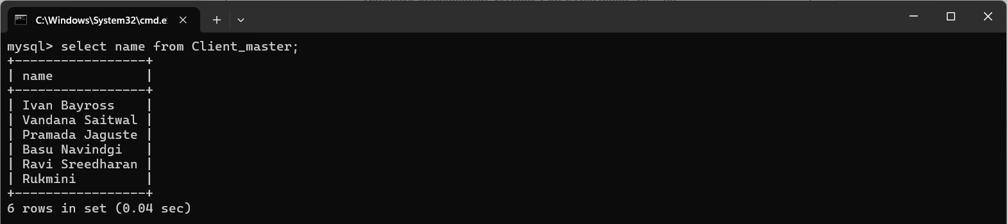

# print the entire client_master table:

Select * from Client_master; Output:

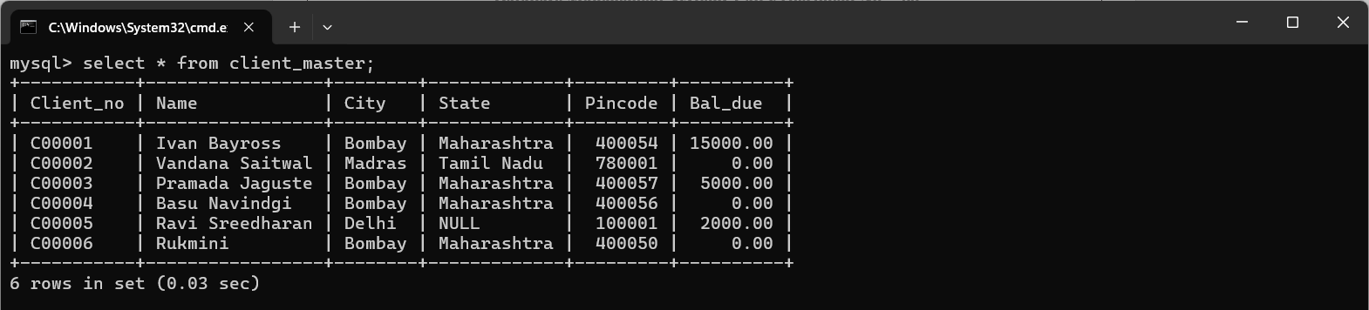

# Retrieve the list of names and the cities of all the clients:

Select name,city from Client_master; Output:

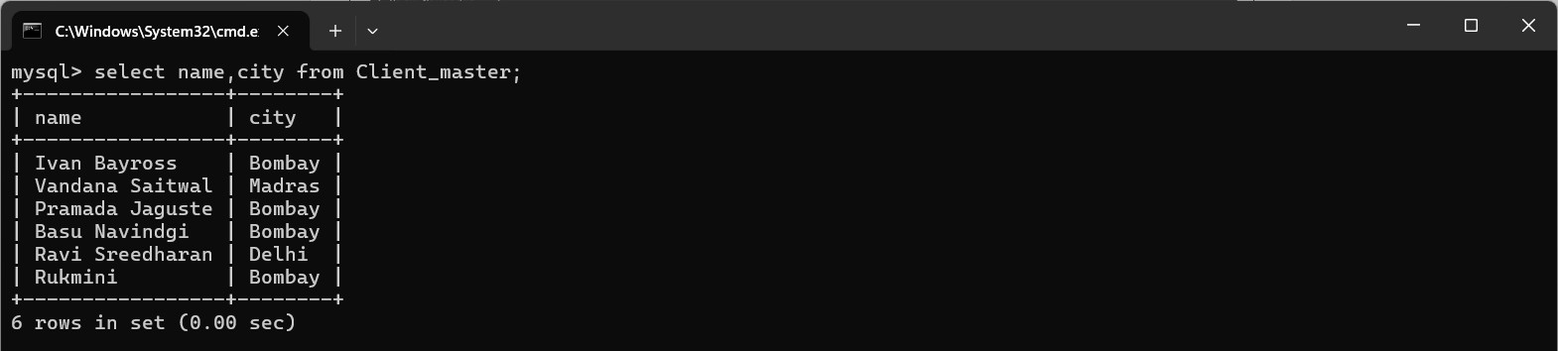

# List the various products available from the product_master:

Select Description from Product_master; Output:

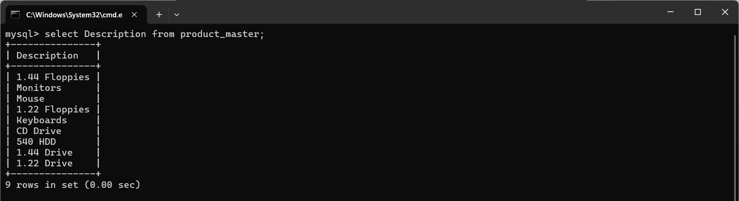

# Find the name of all clients having 'a' as the second letter in their names:

Select Name from Client_master where like ‘_a%’; Output:

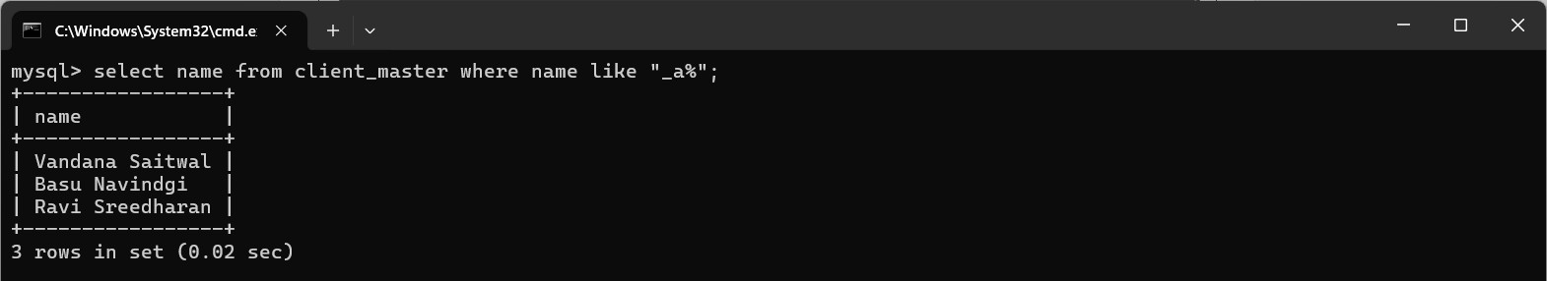

# Find out the clients who stay in city whose second letter is 'a' :

Select city from Client_master where city like ‘_a%’; Output:

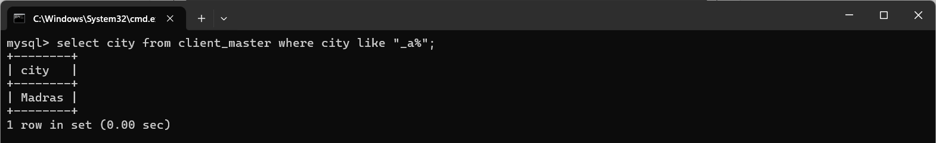

# Find the list of all clients who stay in bombay or city delhi or city madras:

Select * from Client_master where city in (‘Bombay’,’Madras’,’Delhi’); Output:

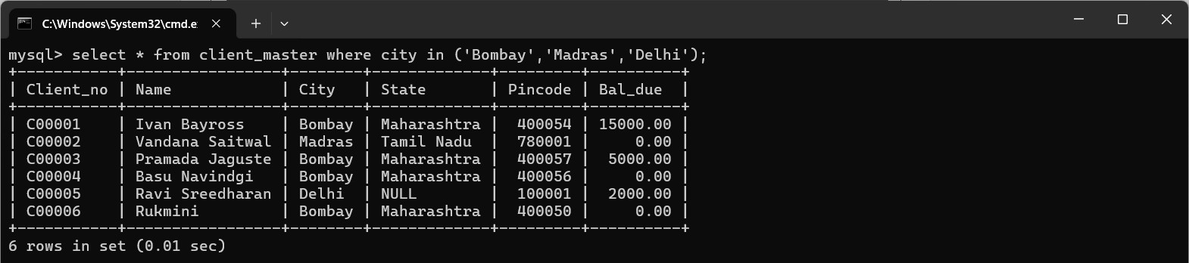

# List all the clients who are located in 'Bombay':

Select * from Client_master where city like ‘Bombay’; Output:

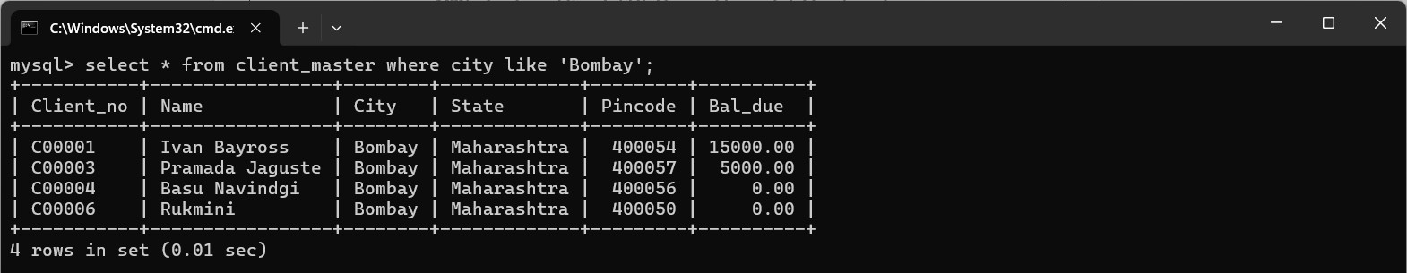

# Print the list of clients whose bal_due are greater than value 10000:

Select * from Client_master where Bal_due >10000; Output:

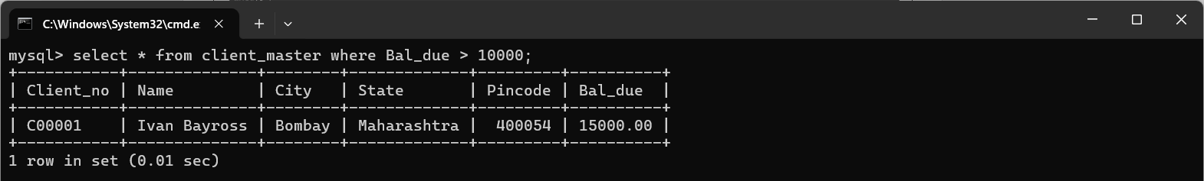

# Print the information from sales_order table of order placed in month of January:

Select * from sales_order where S_order_date like ‘ -01- ’; Output:

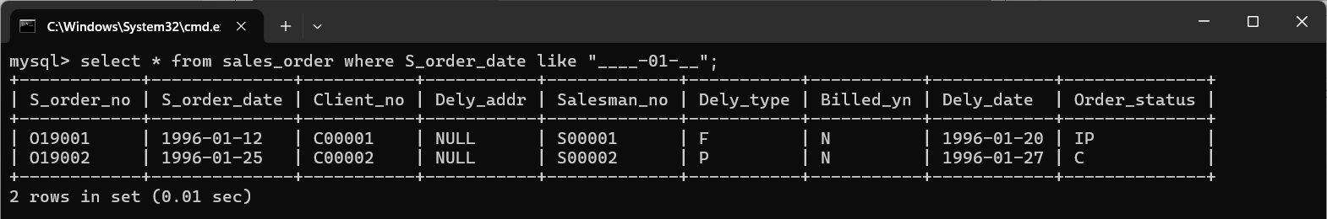

# Display order information for client_no 'c00001' and 'c00002' ;

Select * from Sales_order where Client_no in (‘C00001’,’C00002’); Output:

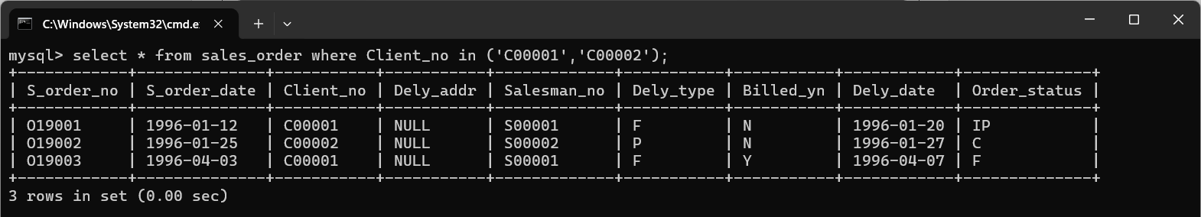

# Find the products with description as '1.44 drive' and '1.22 drive' :

Select Product_no,Description from Product_master where Description =’1.44 Floppies’ or Description =’1.22 Drive’;

Output:

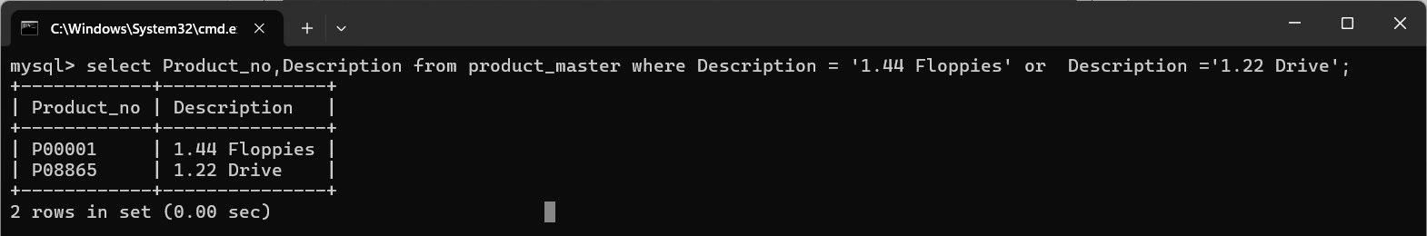

1. **Find the product whose selling price is greater than 2000 and less than or equal to 5000:**

Select * from Product_master where Sell_price > 2000 and Sell_price<=5000; Output:

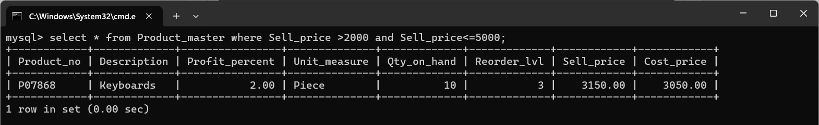

# Find the product whose selling price is more than 1500 and also find the new selling price as original price * 15:

Select Product_no,Description,Sell_price,Sell_price* AS ‘new selling price ’ from Product_master where Sell_price>1500 ;

Output:

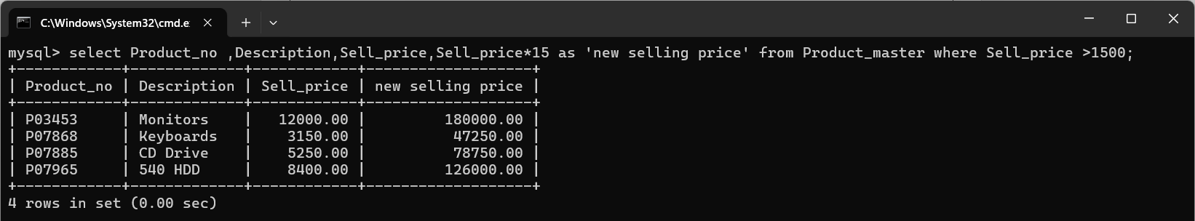

# Rename the new in the above query as new_price:

Select Sell_price * 15 AS ‘new_price’ from Product_master; Output:

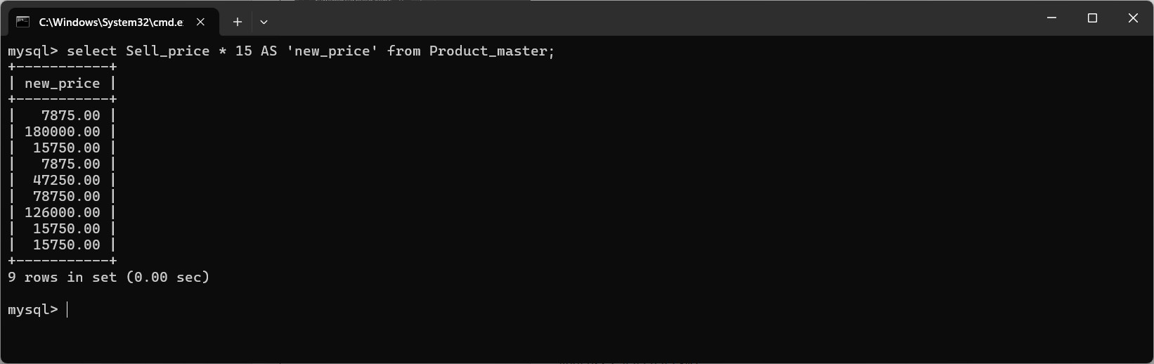

# Find the product whose cost price is less than 1500

Select * from Product_master Cost_price <1500; Output:

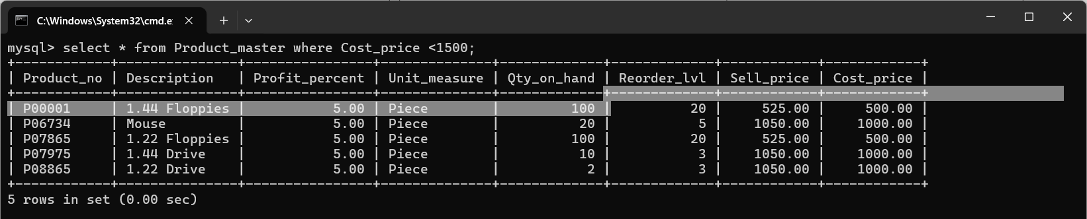

# List the product in sorted order of their description:

Select * from Product_master order by Description; Output:

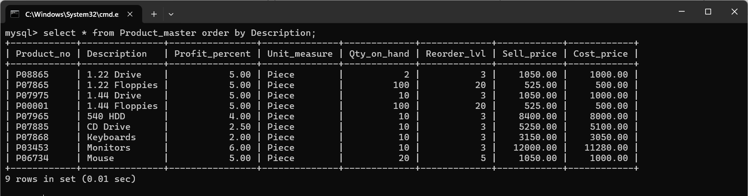

# Calculate the square root of price of each product:

Select Sell_price ,sqrt(Sell_price) from Product_master; Output:

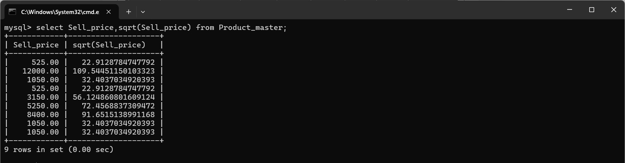

# Divide the cost of product '540 HDD' by /difference between its price and 100:

Select Cost_price/(Cost_price-100) from Product_master where Description like ‘540 HDD’; Output**:**

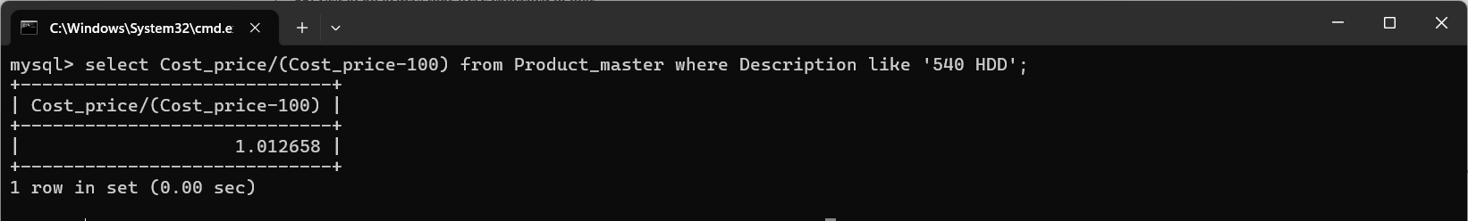

# List the names,city,state of clients not in the state of 'Maharashtra' :

Select Name,City,State from Client_master where State not like ‘Maharashtra’; Output:

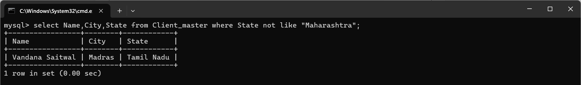

# List the product_no,description,sell_price of products whose description begin with letter 'M' :

Select Product_no,Description,Sell_price from Product_master where Description like ‘M%’;

Output:

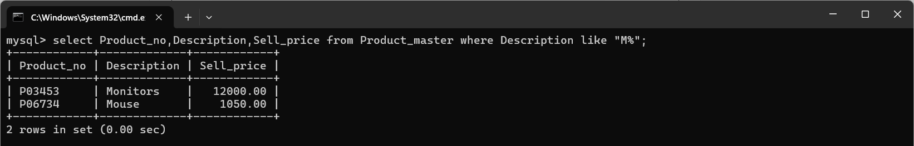

# List of all orders that were cancelled in month of May.

Select * from sales_order where S_order_date like ‘ -05- ’ and Order_status like ‘C’; Output:

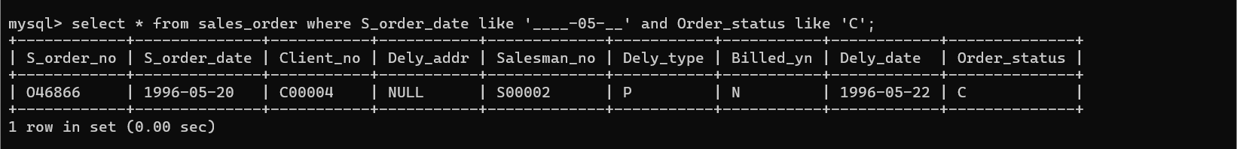

Conclusion: LO2, LO3 mapped